Case 11-US-MA-Natick Indian Graves-Bacon Free Library Grounds-1905

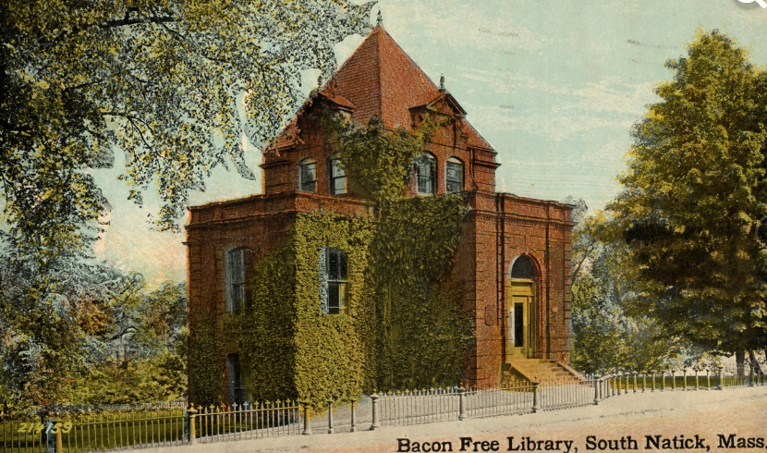

The actual grave yard of the Natick Indians was on the grounds of the Bacon Free Library which was built in 1880. The gravestones were removed from the graves and placed in a retaining wall of the library grounds to the left of this photograph.

The description below is from https://www.findagrave.com/cemetery/2337792/south-natick-burial-ground:

“At a town meeting of the Indian inhabitants in 1731 it was voted unanimously to give an acre of land behind the meeting-house to Rev. Oliver Peabody and the English for a Burial Ground forever. This land was adjacent to the actual burial sites of the Praying Indians, which are unmarked, except that of [Daniel Takawambait](https://www.findagrave.com/cgi-bin/fg.cgi?page=gr&GRid=121395486).”  
[This statement is incorrect as the actual burying grounds are on the site of the present Natick Public Library and the gravestones which were clearly marked have been thrown helter-skelter into a retaining wall of these grounds which were formalized in 1905.]

“The earliest burial is 1733.” [This is also incorrect since the actual 17th c burials began under the first Minister of the Praying Indians Rev. John Eliot in 1660. Earlier aboriginal graves were on the site of the Bacon Free Library as well.] “There is no longer any space for further burials.”  
  
The Massachusetts Historical Commission refers to this cemetery in MACRIS as *NAT.800 South Natick Burial Ground*.”  
  
“This cemetery is referred to as *GR3 South Natick Cemetery, Eliot Square* in the "Vital Records of Natick Massachusetts to the end of the year 1849."

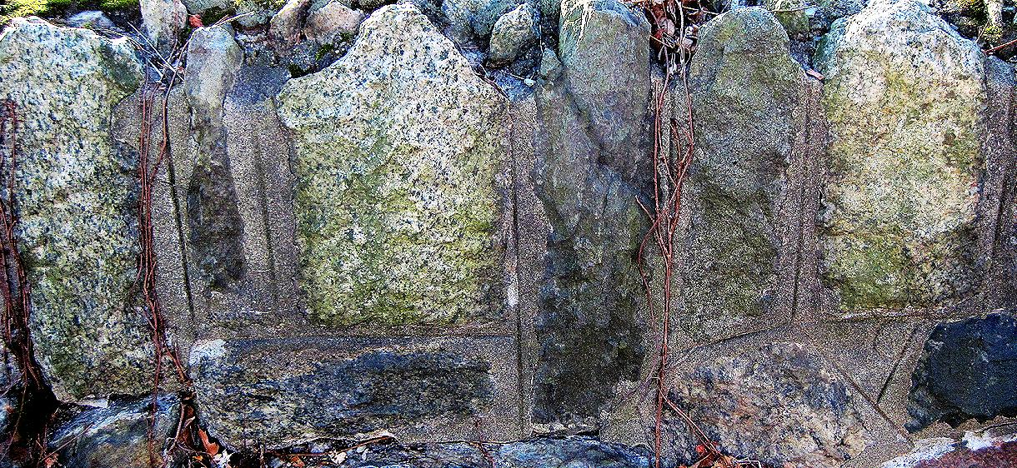

Manitou Graves stones 1-6- Bacon Free Library retaining wall, 1905

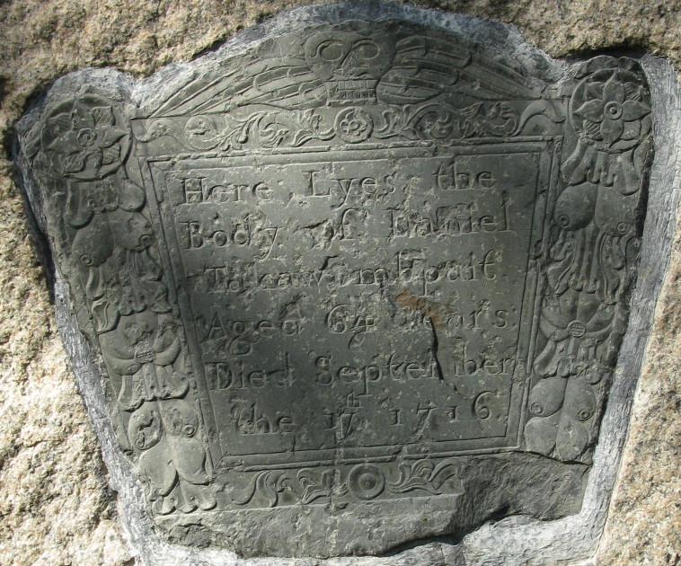

Rev Daniel Takawambpait’s IndianManittou grave stone

|  |  |
| --- | --- |
| Birth | 1652 |
| Death | 17 Sep 1716 (aged 63–64)  Natick, Middlesex County, Massachusetts, USA |
| Burial | [Indian Burial Ground](https://www.findagrave.com/cemetery/2522751/indian-burial-ground) [incorrect]  Next to the First Church of Natick, South Natick, Middlesex County, Massachusetts, USA |
| Memorial ID | 121395486 · |
|  |  |

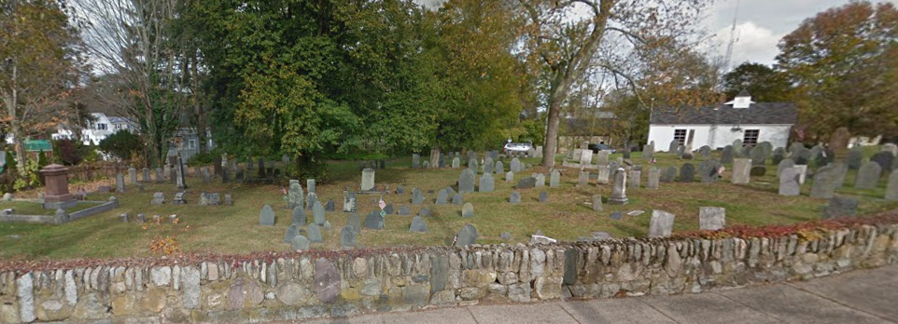

The so-called Indian brial ground across the road from the First Church of Natick. Not one Natick Indian grave is listed here.

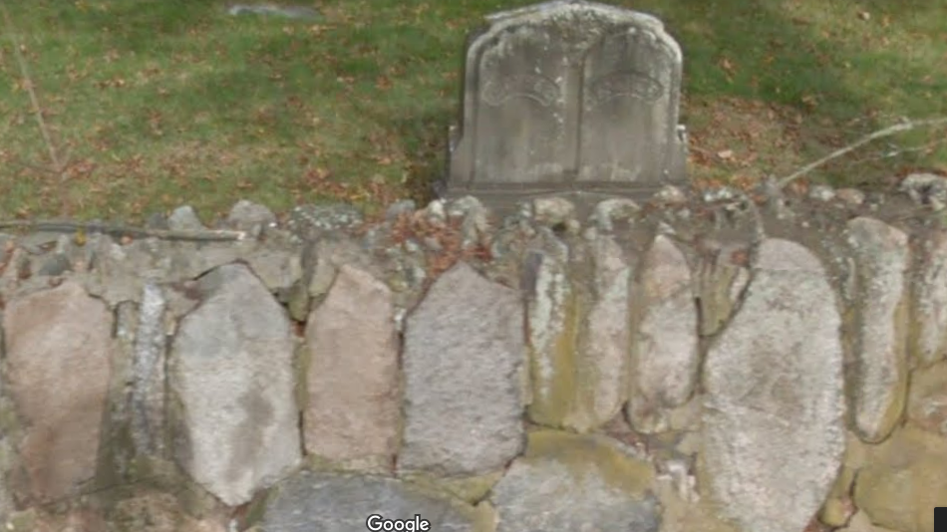

Manitou Graves stones set in a wall of the so-called Indian Burying Ground.

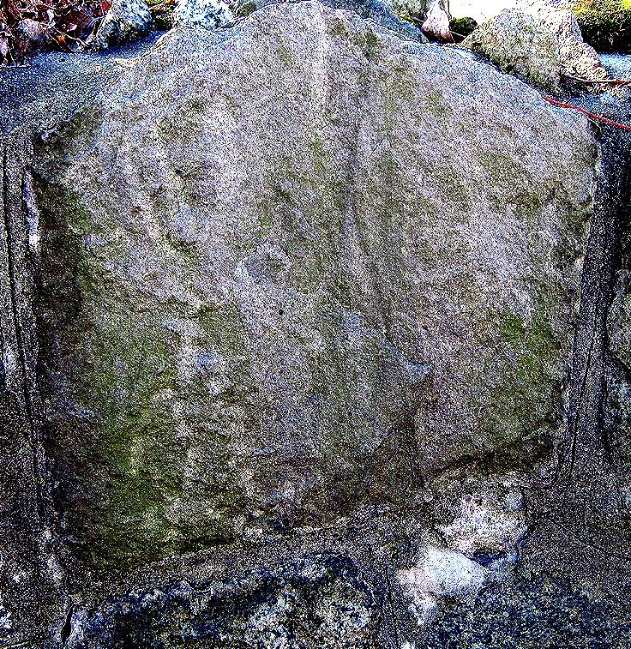

Natick Town Park Manitou Gravestone-Classic Algonquian truncated shape, with four petroglyphs lightly engraved. Left Nanibozo the Hare, Nanabozo the Raven, Natick shaman----------------------------------Nanabozo the Coyote

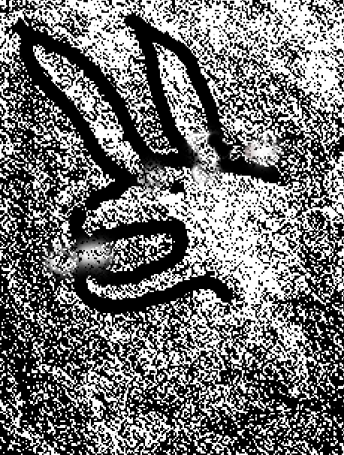

Left Nanibozo the Hare, Nanabozo the Raven, shaman-----Nanabozo the Coyote

Nanabozo (Nanabozho or Nanabush) is a mythological culture hero found from the Great Lakes to the Eastern Seaboard. Nanabozo is the personification of life, with the power to create life in others. Her/his gender is undefined and changeable. S/he also appears as diverse personalities and forms - including a hare, a raven, and a coyote, - which represent the various phases of the cycle of birth-death and rebirth as is depicted on this Manitou Gravestone. The interpretation of this scene implies that the Natick shaman is summoning the various guises of Nanabozo to indicate to the deceased that like Nanabozo s/he will also assume many different forms in the afterlife. 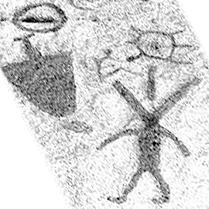

# Nanabozo the hare (center) from the petroglyphs at Peterborough, Ontario. Here Nanabzo is the tranformer showing how the deceased (upper left truncated Manitou gravestone figure) will be transformed into other forms in the afterlife such as a turtle (directly above Nanabozo). Nanabozo as a bird with hare’s ears and bird wings (left) carrying 15 deceased to the afterlife, being directed by Nanabozo, the hare-manitou (right). Pictographs on the rock, Mazinaw Lake, Bon Echo Provincial Park, Ontario.